***“Original by Palmer” - 60’s Catalogue Model 5 ‘De Luxe’ Custom Pool Cue***

I have been told this is the 60’s Palmer Model 5 ‘De Luxe’ custom cue from catalogue 1. (SEE - 60s Catalogue 1 - Model 5 ‘De Luxe’ below for comparison.) It looks to be true considering the size of the “Original By Palmer” customization window and shorter butt end. There is a little more customization on this cue from the base model 5. Looks very similar to the Catalogue 3 – Model 14 also. Nickel silver joint. 20 oz. with 13mm shaft attached. Really nice shape. Original, not refinished. Gorgeous patina as it is. Everything is intact. Incredible detail on forearm. 3 points in perfect symmetry, one point off by 3mm. Has 4 subtle veneer colors, very dark inner points, and very, very fine detail. Upright storage in case since 1984 until recent irish linen re-wrap of handle (original ivory colored irish linen wrap was chalk stained and marked up with a hideous design and initials of previous owner). Silver foil band under very large window with “Original by Palmer” (no custom owner name). 2 shafts – palmer 12mm shaft rolls perfectly flat with base; original 13mm shaft ever-so-slightly off flat. Really nice shooting cue. Very solid feel with both shafts. Rare 60’s-70’s Brunswick 3 slot red felt leather case, (tape wrapped at bottom because of bottom seam split). Original owner slammed the butt end into the case bottom when I won it from him in 1983, which split the bottom seam slightly. I had forgotten I had this until I found it a few months ago, stashed with some of my other treasures that have been in storage for the last 40 years. Had no idea of what I had until I took it in for a re-wrap.

**Catalogue 1 (60’s) – Palmer Cues – This would be the 5 + an extra 12mm Shaft**

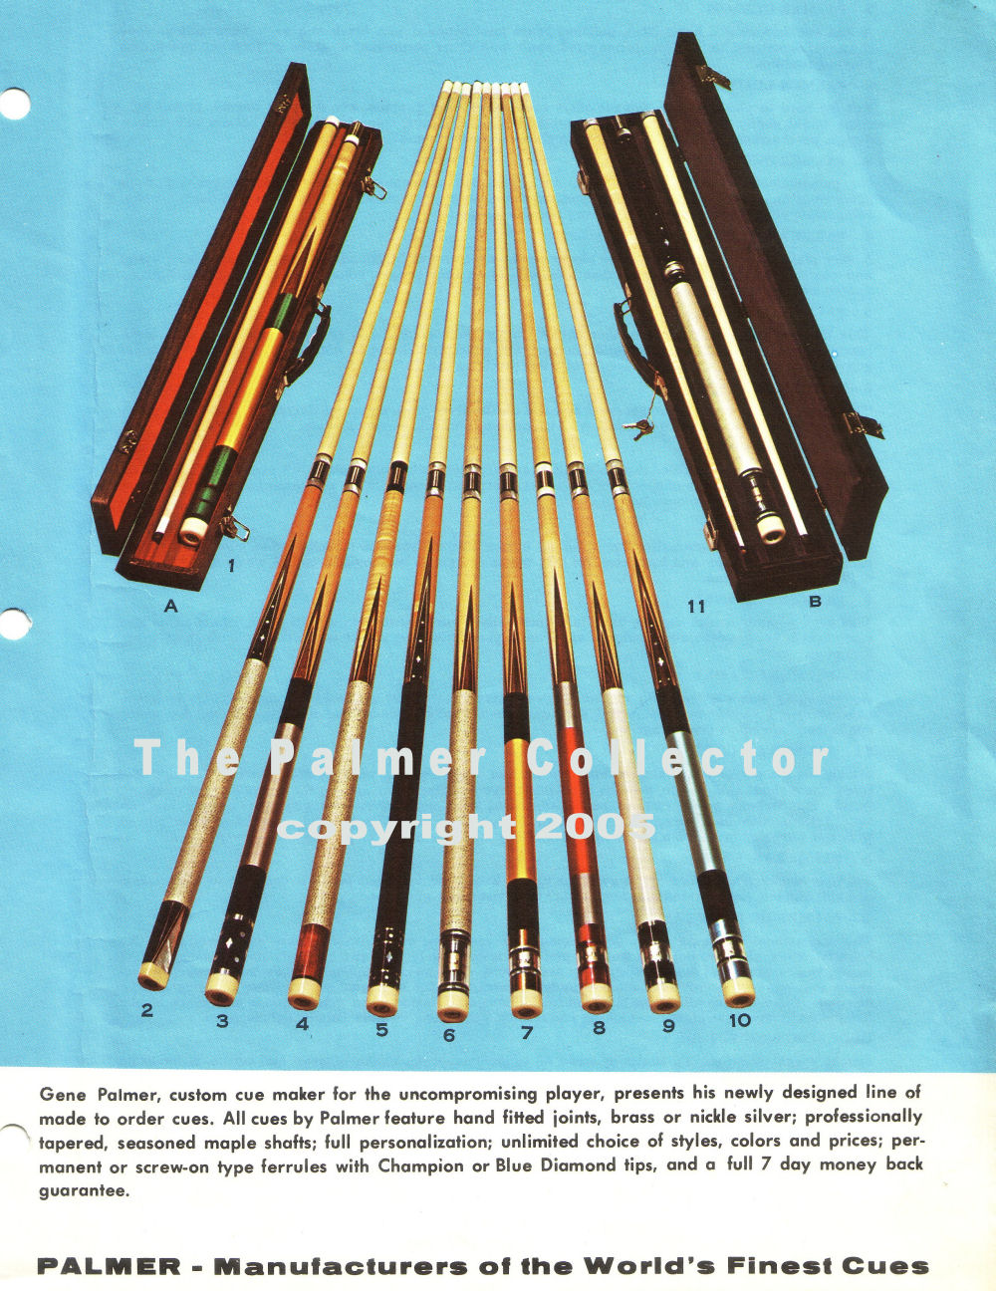

***Here is a cue exactly like mine that was sold at an auction site in 2021, refinished, but without extra shaft. My veneers have more color…..***

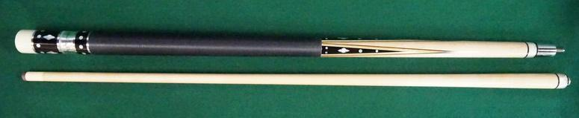

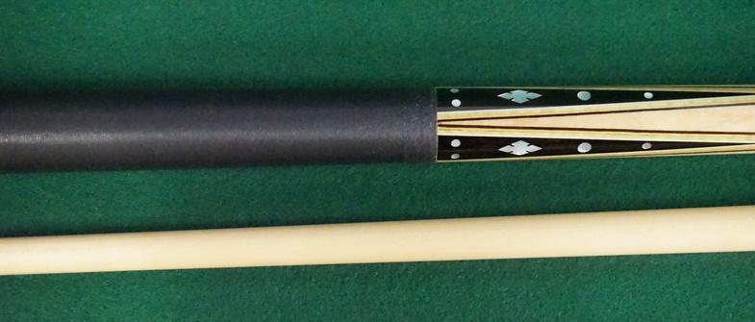

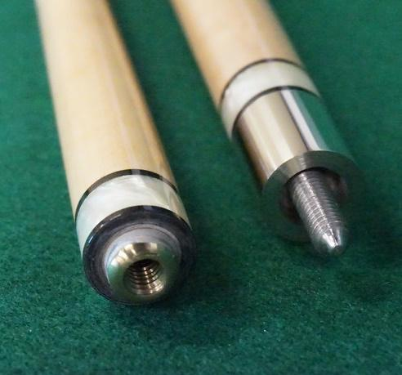

Circa 1965; butt: 28 1/2", 15.9 oz.; shaft: 28 3/4", 4.2 oz, 12.6mm; total length 57", 20.1 oz; points with four veneers, linen wrap, straight, 40 MOP inlays; window reads "Original by Palmer" on silver foil;